DBMS ASSIGNMENT - 5

**BY: GROUP 12**

**JAGADEESH C (18BCS033)**

**DARSHAN R P (18BCS023)**

**ARUN KUMAR S M (18BCS013)**

**G NIKHIL KRISHNA (18BCS030)**

**KUNCHARLA GIREESH KUMAR (18BCS035)**

**KUMPATLA SAI GANESH NAIDU (18BCS044)**

**Tables**

Department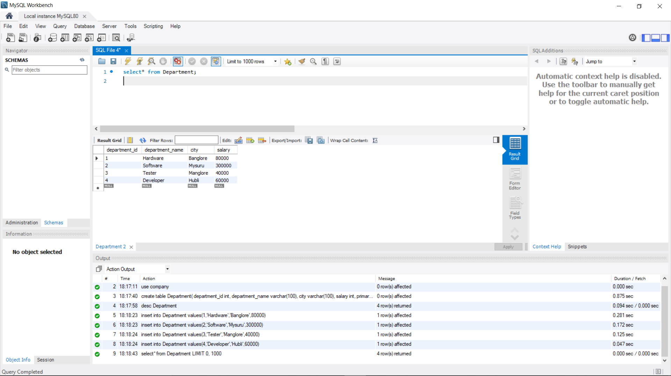

Employees

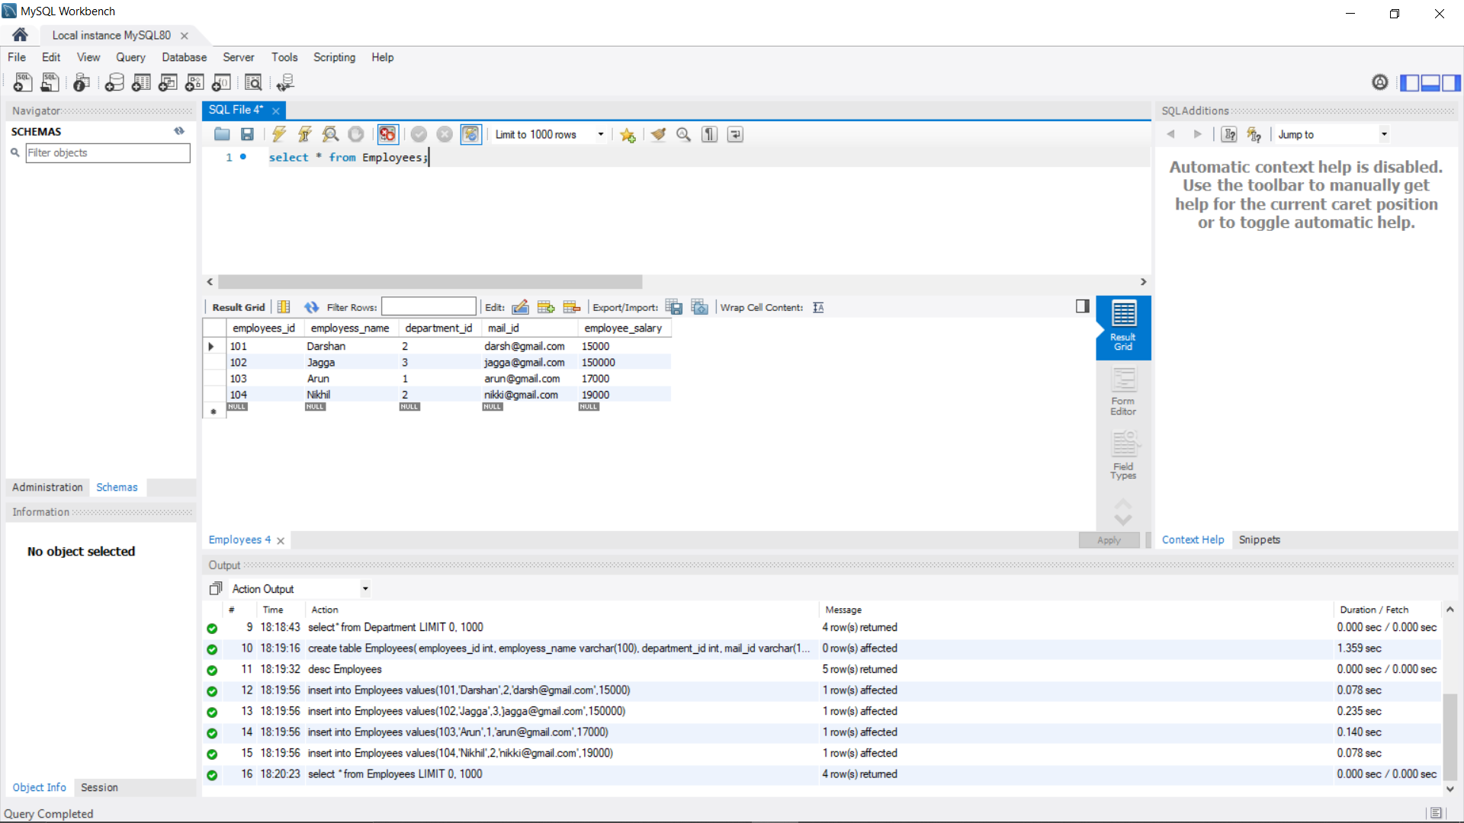

(1).inner join

a) Inner join Department and Employees based on department_id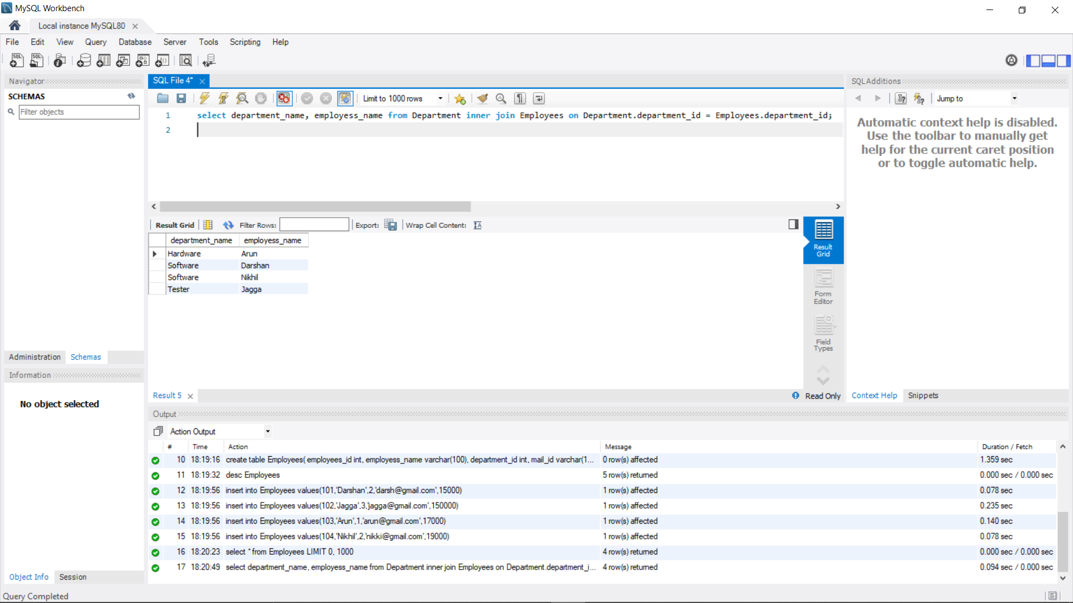

b) Inner join Department and Employees based on department_id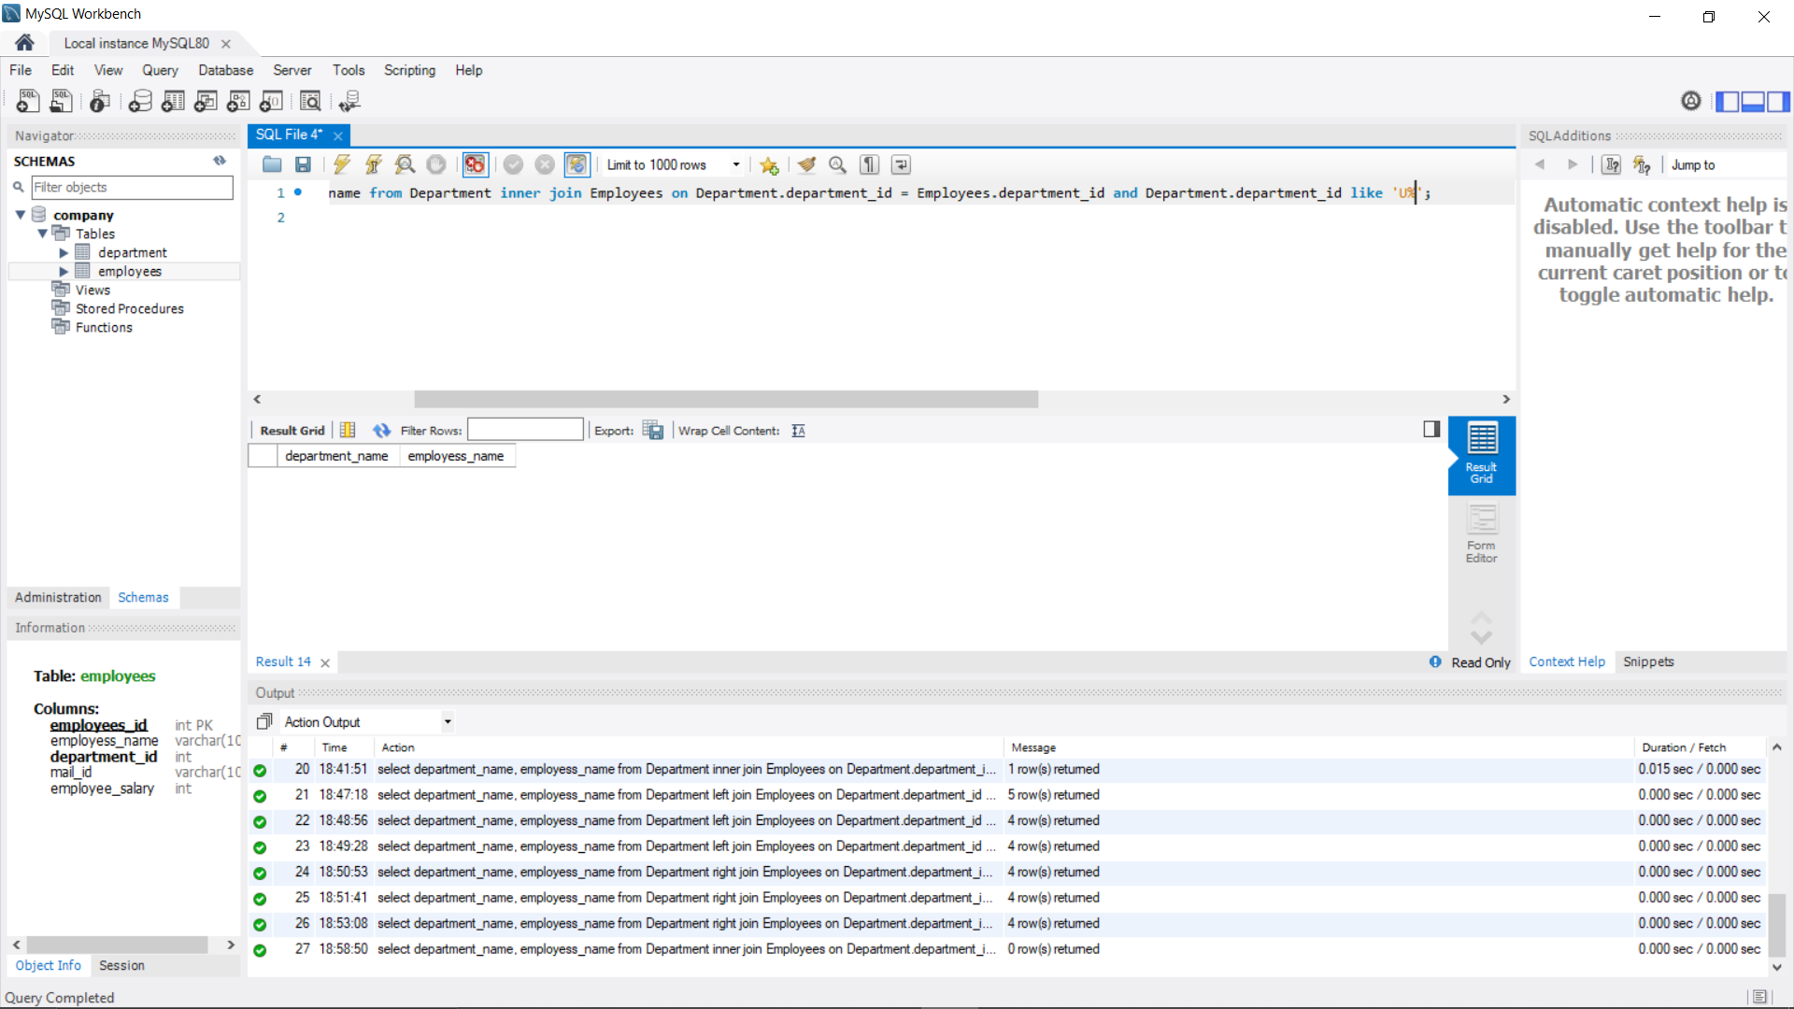

c) Inner join Department and Employee based on department_id >2

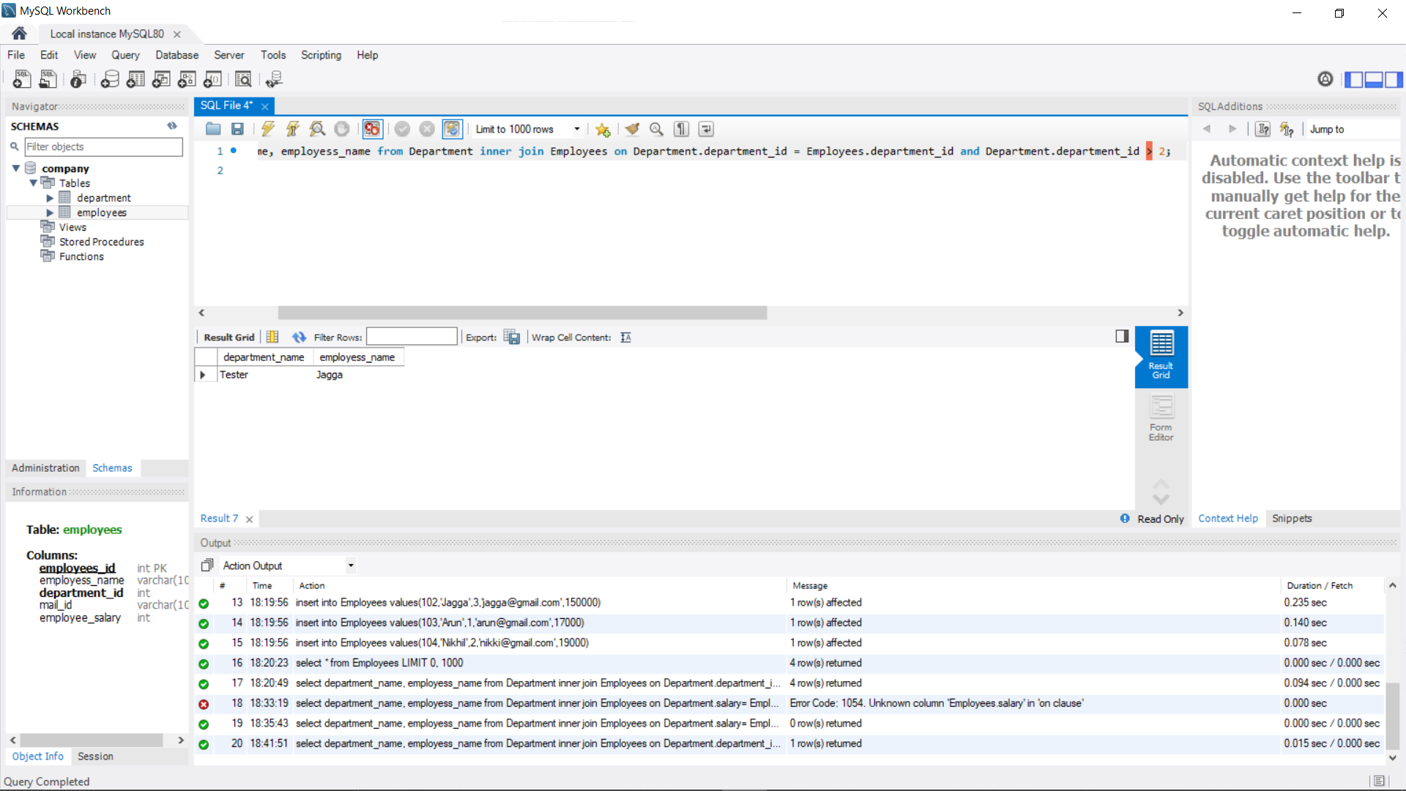

|  |
| --- |
| (2).Left join |

1. Left join Department and Employees based on department_id

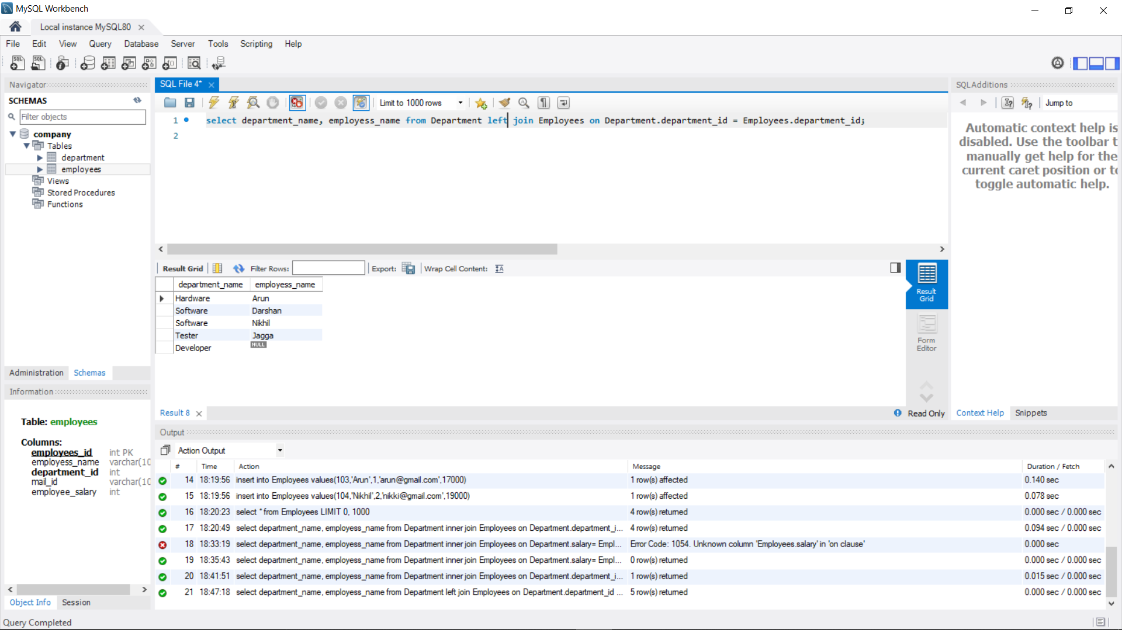

1. Left join Department and Employees based on department_id

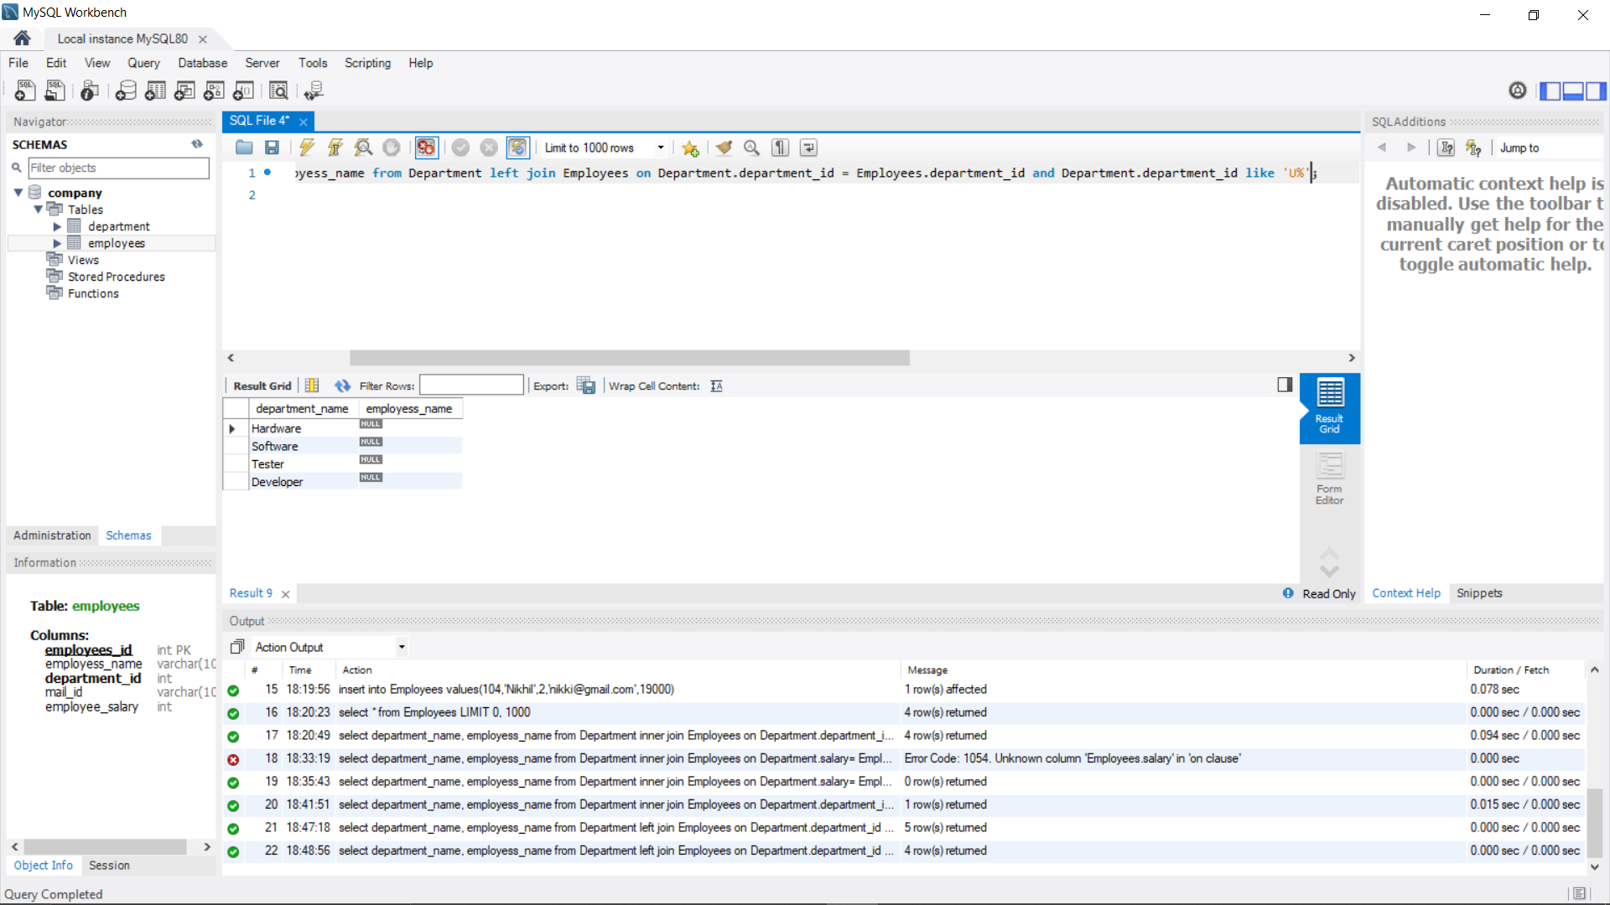

1. Left join Department and Employee based on department_id >2

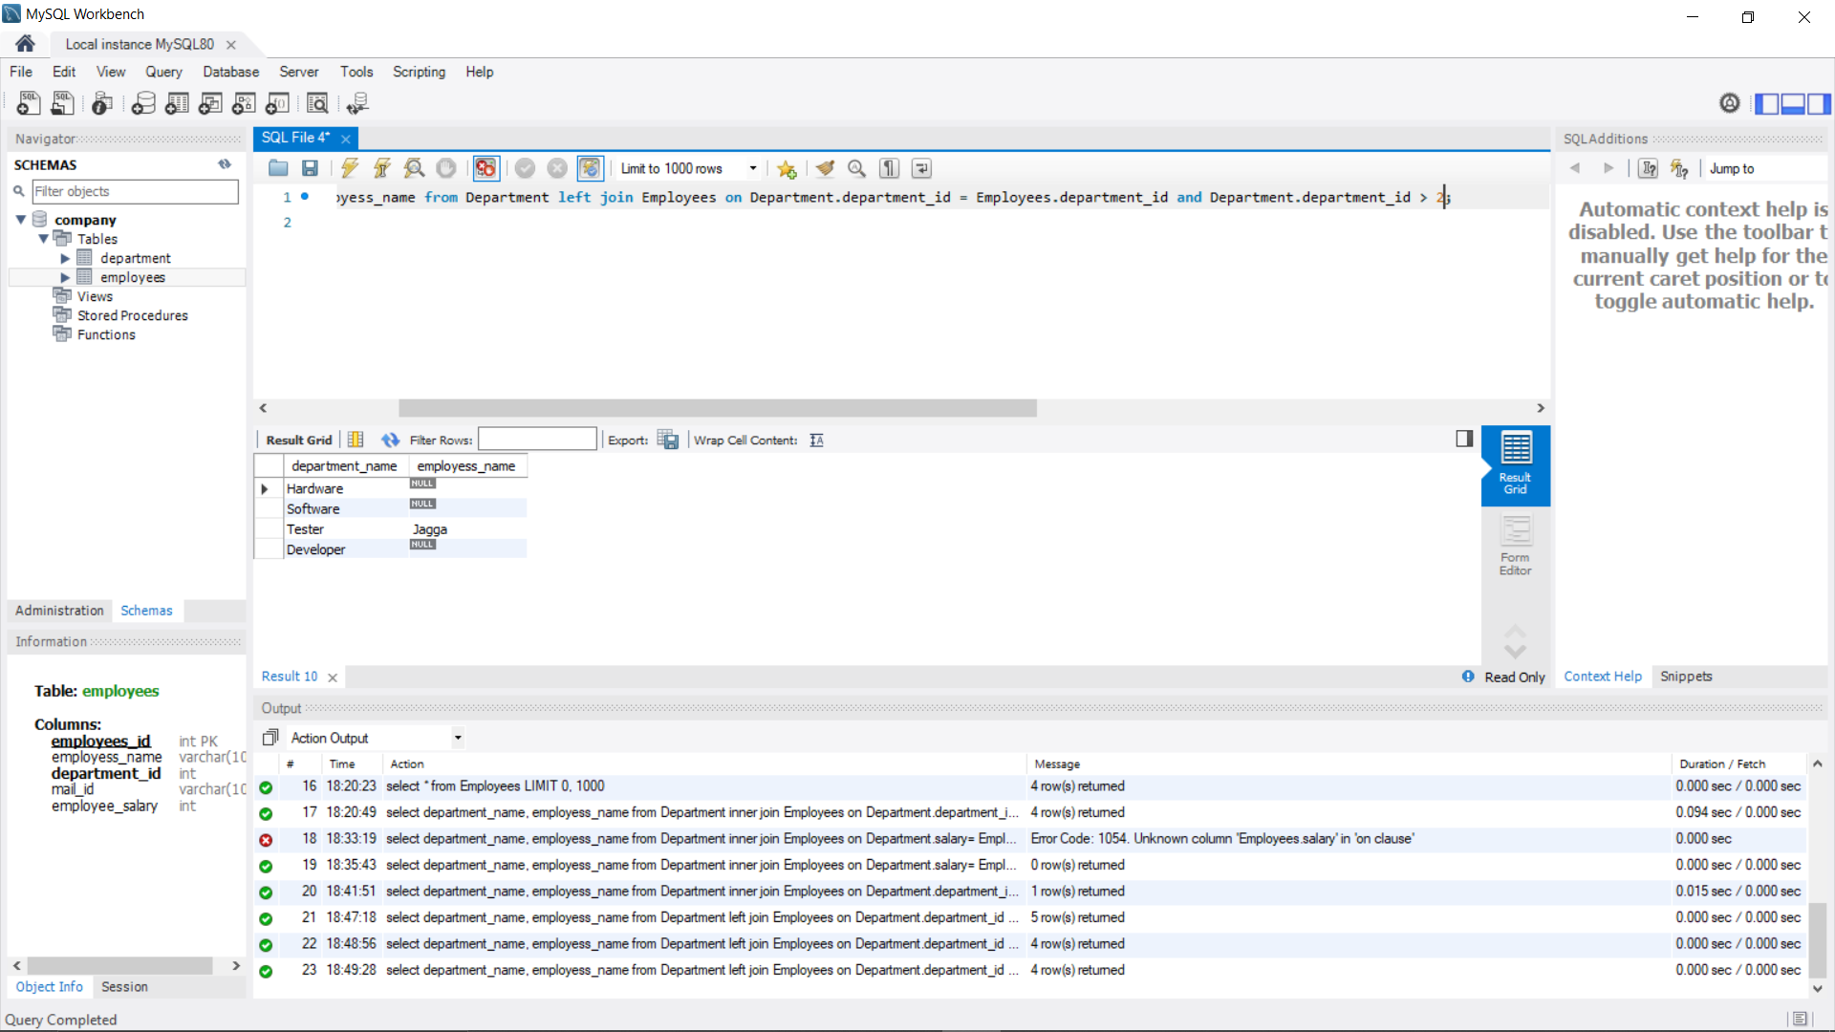

|  |
| --- |
| (3). Right outer Joins |
|  |

|  |
| --- |
|  |

1. Right outer join Department and Employees based on department_id

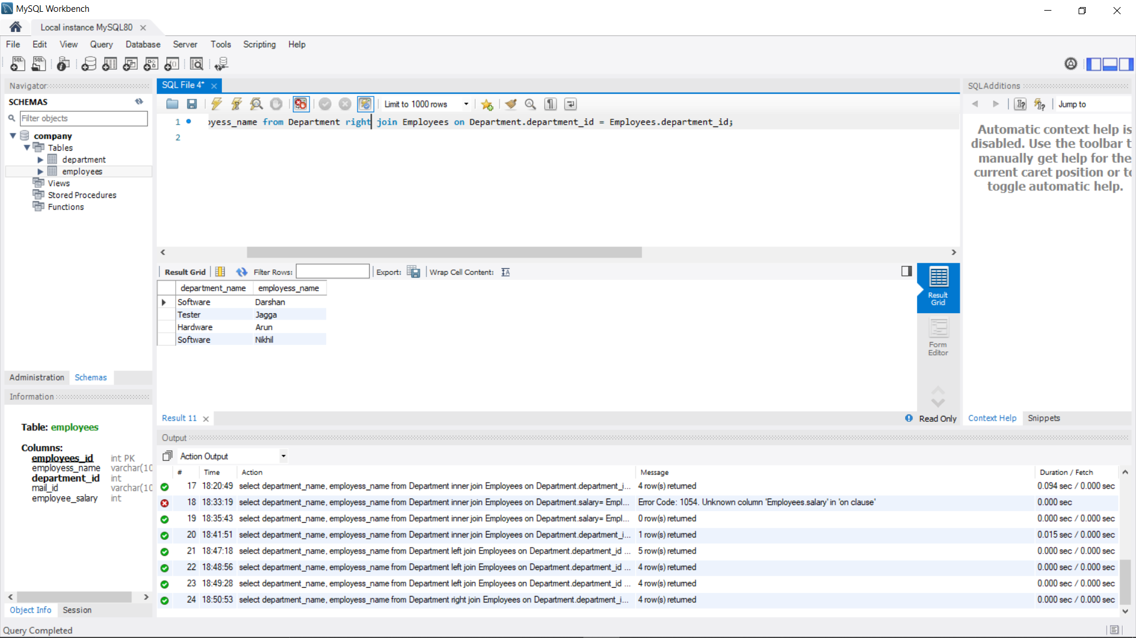

1. Right outer join Department and Employees based on department_id

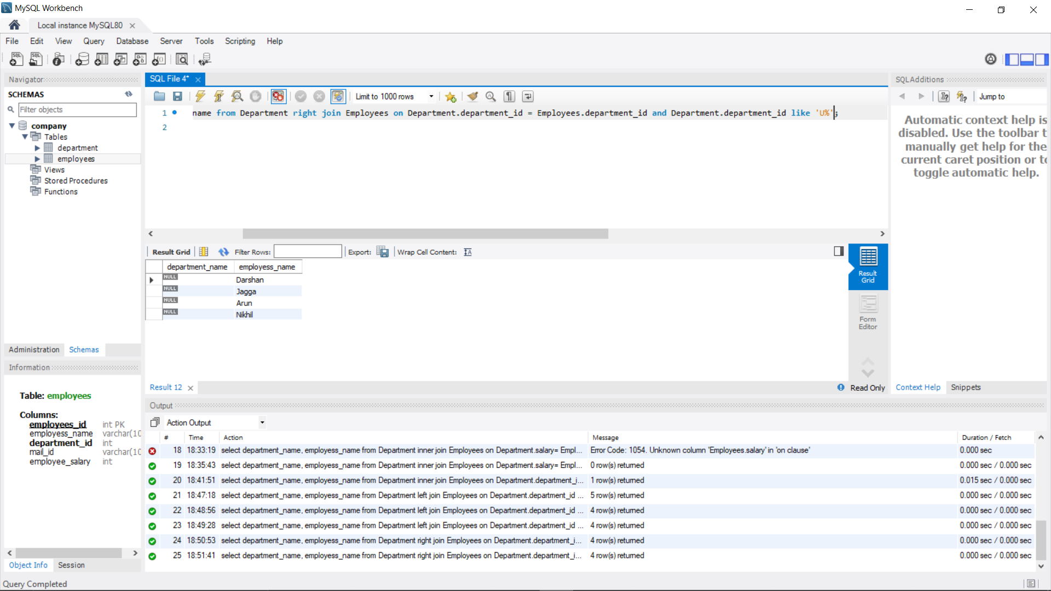

1. Right outer join Department and Employee based on department_id >2

